PAM DMA Implementation Guidelines – DRAFT

**Background**

Trigger Criteria

Criteria to indicate right whale presence will be specific to each near real-time passive acoustic monitoring system. Acoustic detections that meet the following criteria may be used to trigger a PAM DMA:

1. The system has been evaluated and such evaluation has been published in the peer-reviewed literature
2. The system has a false detection rate of 10% or lower over daily time scales
3. The missed detection rate is 50% or lower over daily time scales

Duration:

A DMA based on PAM will be triggered for 15 days, consistent with those triggered by visual sightings

Size:

A PAM DMA will be represented by the rectangular area encompassing a circle with a radius of 20 nautical miles around the location of the passive acoustic monitoring system.

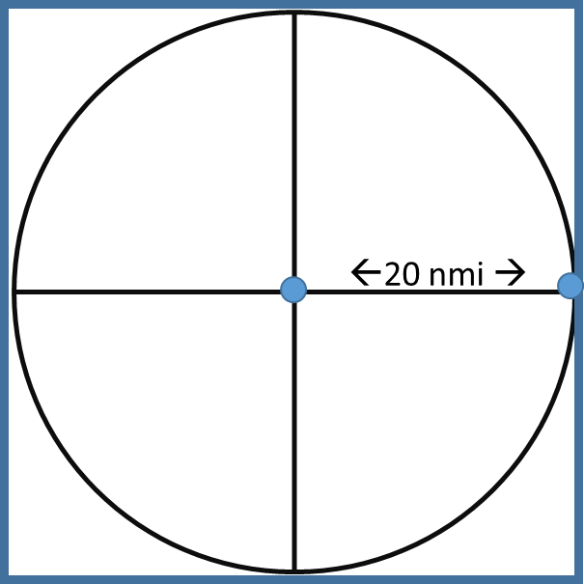

**Scenario Planning: Integration of Acoustic & Visual DMA Determination**

Scenario 1**:** PAM event triggers DMA

* Initial DMA is set for 15 days
* If additional NARW up-calls are acoustically detected in the second week (starting day 8/9), the PAM DMA is extended another 15 days and “clock” is reset.
* OR, if an aerial survey conducted during the second week (starting day 8 or 9?) identifies 3+ whales meeting visual survey DMA criteria, the PAM DMA is extended another 15 days and “clock” is reset.

Scenario 2: Visual sightings trigger DMA

* Initial DMA is set for 15 days
* If DMA encompasses PAM system, then acoustic detections may be used to extend visual DMA. Otherwise, any acoustic detections would trigger a separate DMA.
* If an aerial survey conducted during the second week (starting day 8 or 9?) identifies 3+ whales meeting visual survey DMA criteria, the PAM DMA is extended another 15 days and “clock” is reset.
* Or, if up-calls are acoustically detected during the second week (starting day 8/9), the visual DMA is extended 15 days and “clock” is reset.

Scenario 3: Mobile PAM

* Initial DMA is set for 15 days based on location of platform at time of acoustic event
* Once mobile platform has exited the 20nmi bounds of the initial DMA, any acoustic detections may trigger a new DMA

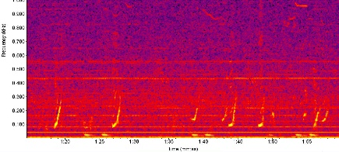

* Based on this protocol, the new DMA may overlap up to 50% of the existing DMA
* This may result in the triggering of DMAs on subsequent days as the mobile platform moves along a survey track
* Extension of any mobile DMA box would be same as for Scenarios 1 & 2.

**Implementation Steps following Visual Protocol**

Case 1: WHOI acoustic platforms

1. Acoustic detection correctly classified as NARW potentially triggers PAM

*Detection is transmitted to dcs.whoi.edu site with time stamp*

1. Detection is reviewed by trained analyst for verification

*Need high confidence in analyst confirmation. Would suggest that Gen take this role.*

1. Location of detection is evaluated relative to existing protections (SMAs, existing DMAs). NOTE: *DMAs will not be triggered within an existing SMA, which affords higher protection*

*Leah has R code to automatically evaluate this, yes?*

1. If new DMA is warranted, DMA area is calculated & lat/longs are determined

*Via Leah’s code…?*

1. Notification to mariners

*Via Tim to Peter K.*

1. Database and reference

*Tim, need guidance here. PAM DMA info should be archived in same database as visual DMA info, or if a new database is established, Leah’s code must interface with both.*